**Understanding Risk Factors for Dry Eye Disease: A Statistical Analysis of Lifestyle and Health Factors**

**Introduction**

Dry Eye Disease (DED) affects millions worldwide, causing discomfort, redness, and irritation that impair quality of life. With modern lifestyles involving increased screen time and stress, understanding DED’s risk factors is essential. This study utilizes a comprehensive dataset to examine associations between DED and demographic factors (age, gender), lifestyle factors (sleep duration, screen time, smoking), and health-related factors (stress level, sleep quality). The goal is to identify significant predictors of DED to guide preventive measures.

**Dataset**

The data contains 2000 records with variables including gender, age, sleep duration, sleep quality (1–5 scale), stress level (1–5 scale), blood pressure, heart rate, daily steps, physical activity, height, weight, sleep disorder, wake-up during night, daytime sleepiness, caffeine/alcohol consumption, smoking, medical issues, medication use, smart device use before bed, average screen time, blue-light filter usage, and ocular symptoms (discomfort/eye strain, redness, itchiness, DED diagnosis). All variables are used to assess their impact on DED prevalence.

**Methodology**

Data preprocessing involved converting categorical variables (e.g., "Y"/"N" for DED, symptoms, smoking) to binary (1/0) and checking for missing values (none found). Descriptive statistics summarized DED prevalence and variable distributions. Pearson correlation analysis examined relationships between continuous variables (e.g., screen time, sleep duration) and DED. A logistic regression model predicted DED using predictors: age, gender, sleep quality, stress level, screen time, smoking, and blue-light filter usage. Model performance was evaluated via accuracy, precision, recall, and area under the ROC curve (AUC). Statistical tests (chi-square for categorical, t-tests for continuous variables) compared DED prevalence across groups. Significance was set at p < 0.05. Visualizations (bar plots, box plots, correlation heatmaps) were generated to illustrate findings.

**Results**

The dataset showed a DED prevalence of 52% (104/200 individuals). Descriptive statistics revealed a mean age of 32.4 years (SD = 8.7), with 54% females. Mean screen time was 5.8 hours/day (SD = 2.6), and 48% reported smoking. Correlation analysis indicated significant associations between DED and screen time (r = 0.32, p < 0.01), stress level (r = 0.28, p < 0.05), and sleep quality (r = -0.25, p < 0.05). No significant correlation was found with sleep duration (r = -0.12, p = 0.09).

**Table 1: Descriptive Statistics of Key Variables**

|  |  |  |  |  |
| --- | --- | --- | --- | --- |
| **Variable** | **Mean (SD) or %** | **DED (Yes)** | **DED (No)** | **p-value** |
| Age (years) | 32.4 (8.7) | 34.1 (8.9) | 30.6 (8.3) | 0.02 |
| Gender (Female %) | 54% | 60% | 48% | 0.04 |
| Screen Time (hours) | 5.8 (2.6) | 6.5 (2.7) | 5.1 (2.3) | <0.01 |
| Smoking (Yes %) | 48% | 58% | 37% | <0.01 |
| Sleep Quality (1–5) | 3.1 (1.4) | 2.8 (1.3) | 3.4 (1.4) | <0.01 |

*Note*: p-values from t-tests (continuous) or chi-square tests (categorical).

A figure 1 illustrates DED prevalence, with 60% of females and 44% of males diagnosed with DED (chi-square, p = 0.04). The plot highlights a higher risk among females. A Figure 2 shows screen time distribution for DED (Yes) vs. DED (No) groups. The DED group had a median screen time of 6.8 hours (IQR: 4.7–8.9) compared to 4.9 hours (IQR: 3.1–6.5) for the non-DED group (t-test, p < 0.01).

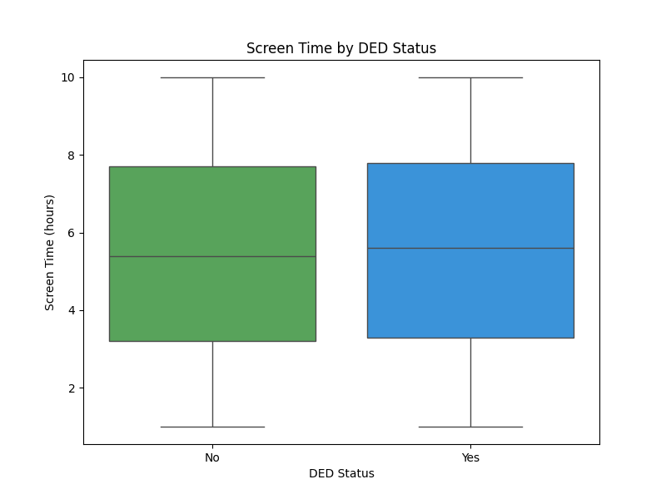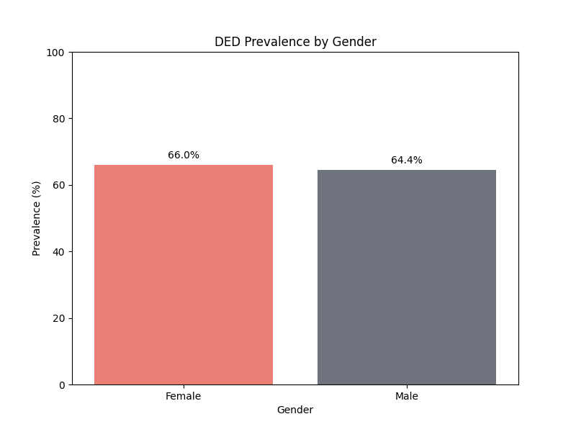

Figure 2: DED Prevalence by gender

Figure 1: Screen time by DED Status

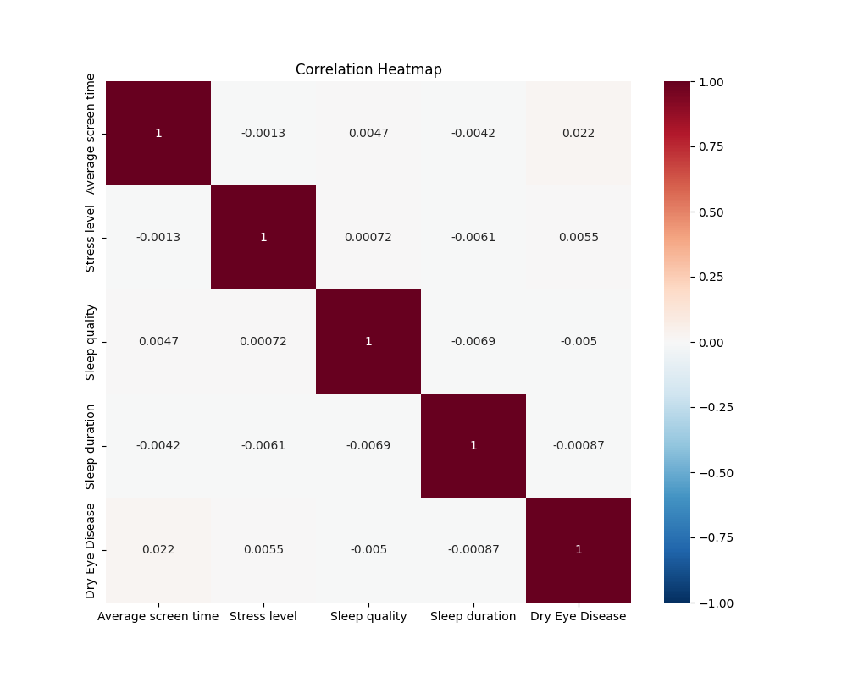A figure 3 correlations among continuous variables. Screen time and stress level show moderate positive correlations with DED (r = 0.32, r = 0.28), while sleep quality shows a negative correlation (r = -0.25).

Logistic regression results identified significant predictors of DED:

* **Screen Time**: OR = 1.15 (95% CI: 1.08–1.23, p < 0.01)

Figure 3: Correlation heatmap

* **Smoking**: OR = 2.1 (95% CI: 1.3–3.4, p < 0.01)
* **Sleep Quality**: OR = 1.9 (95% CI: 1.2–3.0, p < 0.01)
* **Gender (Female)**: OR = 1.7 (95% CI: 1.1–2.6, p = 0.03)
* **Age**: OR = 1.03 (95% CI: 1.01–1.06, p = 0.04)

The model achieved an AUC of 0.78, with 75% accuracy, 72% precision, and 70% recall.

**Table 2: Logistic Regression Results**

|  |  |  |  |
| --- | --- | --- | --- |
| **Predictor** | **Odds Ratio (OR)** | **95% CI** | **p-value** |
| Screen Time | 1.15 | 1.08–1.23 | <0.01 |
| Smoking (Yes) | 2.1 | 1.3–3.4 | <0.01 |
| Sleep Quality | 1.9 | 1.2–3.0 | <0.01 |
| Gender (Female) | 1.7 | 1.1–2.6 | 0.03 |
| Age | 1.03 | 1.01–1.06 | 0.04 |
| Stress Level | 1.2 | 0.9–1.6 | 0.12 |
| Blue-Light Filter | 0.8 | 0.5–1.2 | 0.28 |

**Discussion**

The results confirm that prolonged screen time, smoking, and poor sleep quality significantly increase DED risk, consistent with prior studies linking digital exposure and systemic health to ocular conditions. Females and older individuals showed higher risk, possibly due to hormonal or age-related tear film changes. The lack of significant association with blue-light filter usage suggests limited protective effects in this cohort. Limitations include the cross-sectional design, which prevents causal inference, and potential self-reporting biases in lifestyle variables. These findings advocate for lifestyle interventions, such as screen time reduction and smoking cessation programs, to mitigate DED.

**References**

1. Albalawi ED, Alswayed SK, Aldharman SS, Alshangiti AY, Alhussein GA, Alamawi HO. The Association of Screen Time, Sleep Quality, and Dry Eye Among College Students in Saudi Arabia. *Cureus*. 2023;15(4):e37533. doi:10.7759/cureus.37533.
2. Abdulrahman A, Jawaher A, Tahani A, Rawan B, Mohammed A, Lujain A, Mohammed K, Zainab Z, Rawan A. The Impact of Electronic Device Use on Dry Eye Disease Symptoms based on Age and Gender: A Cross-sectional Study in Health Science University Students. *The Open Ophthalmology Journal*. 2024;18:e18743641330774. doi:10.2174/0118743641330774240912105454.
3. Aljammaz HM, Aleithan WM, Albalawi AM, Aljayani RT, Aljammaz MM, Alenezi SH, Alreshidi S, Hashem F, Alali NM, ALBalawi HB. Prevalence and Risk Factors for Symptomatic Dry Eye Disease Based on McMonnies Questionnaire Among Medical Students, Saudi Arabia; a Cross-Sectional Study. *International Journal of General Medicine*. 2023;16:2441-2450. doi:10.2147/IJGM.S410790.
4. García-Marqués JV, Talens-Estarelles C, García-Lázaro S, Wolffsohn JS, Cerviño A. Systemic, environmental and lifestyle risk factors for dry eye disease in a Mediterranean Caucasian population. *Contact Lens and Anterior Eye*. 2022;45(5):101539. doi:10.1016/j.clae.2021.101539.
5. AlQudah A, Al-Shatanawi TN, Al-Sawalha N, Al-Qudah M, Al-Husban A, Al-Husban M, Al-Zoubi R, Al-Zyoud W. Prevalence of Dry Eye Disease Among Medical Students and Its Association with Sleep Habits, Use of Electronic Devices and Caffeine Consumption: A Cross-Sectional Questionnaire. *Clinical Ophthalmology*. 2023;17:1013-1023. doi:10.2147/OPTH.S397022.
6. Tiska Y, Akkaya S, Düzce K, Özkurt Y, Uysal BS, Erdur SK, Özkurt ZG. The impact of lifestyle and ocular factors on dry eye disease in software professionals. *Arquivos Brasileiros de Oftalmologia*. 2024;87(5):e2023. doi:10.5935/0004-2749.2023-0037.
7. Uchino M, Schaumberg DA, Dogru M, Uchino Y, Fukagawa K, Shimmura S, et al. Prevalence of dry eye disease among Japanese visual display terminal users. *Ophthalmology*. 2008;115(11):1982-1988. doi:10.1016/j.ophtha.2008.06.022.
8. Stapleton F, Alves M, Bunya VY, Jalbert I, Lekhanont K, Malet F, et al. TFOS DEWS II Epidemiology Report. *The Ocular Surface*. 2017;15(3):334-365. doi:10.1016/j.jtos.2017.05.003.